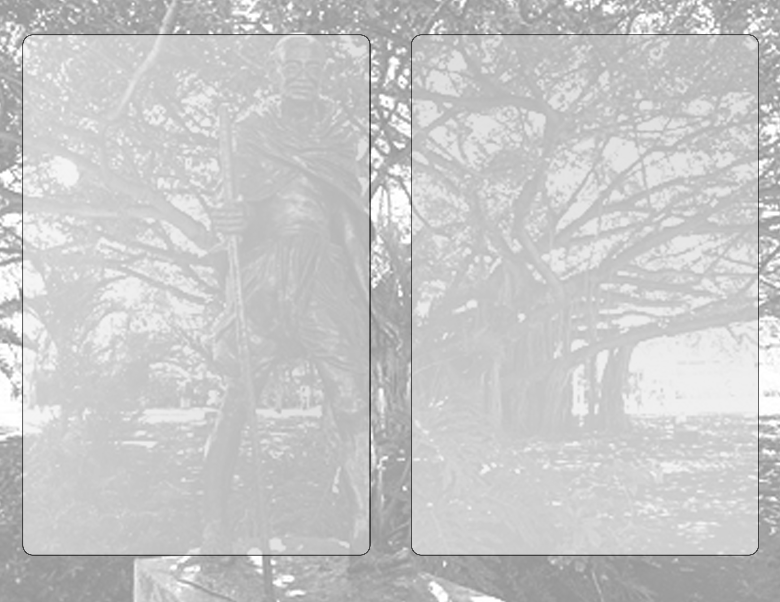,

**GIIP Program Schedule**

**5:00 – 6:30 pm, October 2, 2017**

**Musical Prelude**

The Royal Hawaiian Band

**Hawaiian Blessing**

Kahu Kamaki Kanahele, Kalena Hewlen, Dr. Terry Shintani, Sooriya Kumar &

U. S. Senator (Retired) Daniel Akaka

**Indian Sacred Offering (Pooja) and chanting**

Madana Sundari, Veda Das and Sundarnanda Das

**National Anthems of Hawai’i Pono’ I, India, and U.S. &**

**“Let there be Peace” song**

The Royal Hawaiian Band

Mr. Clarke Bright, Band Master

Ms. Susan Ishida, Band Manager

**Welcome Speech**

Raj Kumar Ph.D.

Founder & President –Gandhi International Institute for Peace

**Hula Dance**

Kumu Malia Helela & Halau, ‘Na Hula Ola Aloha’

**Keynote Speaker**

**Chris Robinson**

U.S. Immigration & Citizenship Services, Honolulu, Hawaii

**Karen Knudsen**

Director, Office of External Affairs

East West Center-University of Hawaii

**Lisa Taylor**

President of Ceeds of Peace

Conflict Resolution through compassion and courage

**Bollywood Dance**

Willow Chang from Bollywood Hawaii

**Proclamation from Hon. Governor David Y. Ige**

**Message from U.S. Senator Mazie K. Hirono**

**Message from Congresswoman Tulsi Gabbard**

Read by Kainoa Penaroza

**Certificates from the Senate and House**

Read by Hon. Senators Kalani English, Brockwood Galuteria and

Hon. Rep. Ken Ito

**Peacemaker Awards Presentation**

UN Ambassador, Philip Jadhav

**ons from Hon. Mayor Kirk Caldwell**

Read by Misty Kelai, Director of Arts and Culture

Read by Councilwoman, Kymberly Pine

**Proclamation from Mayor Kirk Caldwell &**

**Certificate from Council of City and County of Honolulu**

Read by Councilwoman, Kymberly Pine

**Dialogue on World Peace with Interfaith Leaders**

Rev. and Bishop Eric Matsumoto- Buddhism

Rev. Ajith Kumar – Christianity

Professor Ramdas Lamb- Hinduism

Dr. Jared Yurow – Judaism

**Divine soul song of song – song of love, Peace & Harmony**

Master Orlena Wong, Master Patrick Sambueno

joined by students of Master Sha Tao Center, Honolulu

**Indian folk dance**

Nada McClellan &

Aaja Nachle Dance group

**“Heal the world” the famous song by Michael Jackson**

Wallen Ellingsong, accordion, Willow Chang, Phil Strauss & friends vocals

**Namaste, Happy Birthday Mahatma Gandhi song**

Funky Diva and group

**Candlelight Ceremony**

Led by Dr. Terry Shintani & Knights of the Orthodox Order of St. John, Prior

**New Plaque of M. K. Gandhi –** Kim Duffett

**Closing remarks & call to action for World Peace**

Harendra Panalal, VP -GIIP

**Acknowledgements**

**Emcees**: Jake steiner and Brooke Botton

**Stage Management Group**: Lyntillus J. Boyd, Eric Bott & Ron Reddick

**Lei Greeters**: Yoo Ran Sung, Emily Osurman, Jake Steiner from `Iolani

High School

**Sound and DJ**: David Lum

**Videographer**: Stacey Bow & Daniel Rafel from Olelo

**Photographers**: Caron Wilberts and Robin Rae

City and County of Honolulu, Waikiki Police, Zoo Staff, Honolulu Star Advertiser, Midweek & Civil Beat newspapers KHON -2, KITV, KHNL

Volunteers from ‘Iolani School & Spark Matsunaga Peace Institute

**Sponsors and Partners of the Program**: Indian-American Friendship Council, Hawaii Health Foundation, Vegetarian Society of Hawaii, Down to Earth, Foodland, MOA Wellness Center, Creative Cuisine, Master Sha’s Tao Healing Center, O’lelo Community Television, Angels in Hawaii, Global Media Productions, Hawaii Health Guide, Still and Moving Center.